**PAMANTASAN NG LUNGSOD NG MAYNILA**

(

University of the City of Manila

)

Intramuros, Manila



**Microprocessor Lab**

Laboratory Activity No. 1

# Familiarization with TinkerCAD

|  |
| --- |
|  |

Score

*Submitted by:*

**Ambalan, John Ace P.**

**<Saturday 1:00-7:00pm> / <CpE 412-2>**

*Date Submitted*

**10-13-2023**

*Submitted to:*

**Engr. Maria Rizette H. Sayo**

const int OUTPUT_PINS[] = {2, 3, 4, 5, 6, 7, 8, 9}; // Renamed LED_PINS to OUTPUT_PINS

bool areOutputsOn = false; // Renamed ledsOn to areOutputsOn, and also made it false initially

int counter = 1; // Renamed decimal to counter and initialized it to 1

void setup() {

Serial.begin(9600); // Initialize the serial monitor

for (int i = 0; i < 8; i++) {

pinMode(OUTPUT_PINS[i], OUTPUT);

}

}

void loop() {

if (counter <= 255) {

displayBinary(counter);

Serial.println(counter); // Output the decimal value to the serial monitor

if (counter == 255) {

if (!areOutputsOn) {

turnOnAllOutputs();

areOutputsOn = true;

Serial.println("Reached 256. All Outputs are ON.");

delay(100); // Keep Outputs on for 100 ms

} else {

turnOffAllOutputs();

Serial.println("All Outputs are OFF.");

delay(100); // Wait for 100 ms before stopping

while (true) {

// Infinite loop to stop the program

}

}

}

delay(200); // Adjust the delay to control the speed of counting.

counter++;

}

}

void displayBinary(int counter) {

for (int i = 0; i < 8; i++) {

int bitValue = (counter >> i) & 0x01;

digitalWrite(OUTPUT_PINS[i], bitValue);

}

}

void turnOnAllOutputs() {

for (int i = 0; i < 8; i++) {

digitalWrite(OUTPUT_PINS[i], HIGH); // Turn on all Outputs

}

}

void turnOffAllOutputs() {

for (int i = 0; i < 8; i++) {

digitalWrite(OUTPUT_PINS[i], LOW); // Turn off all Outputs

}

}

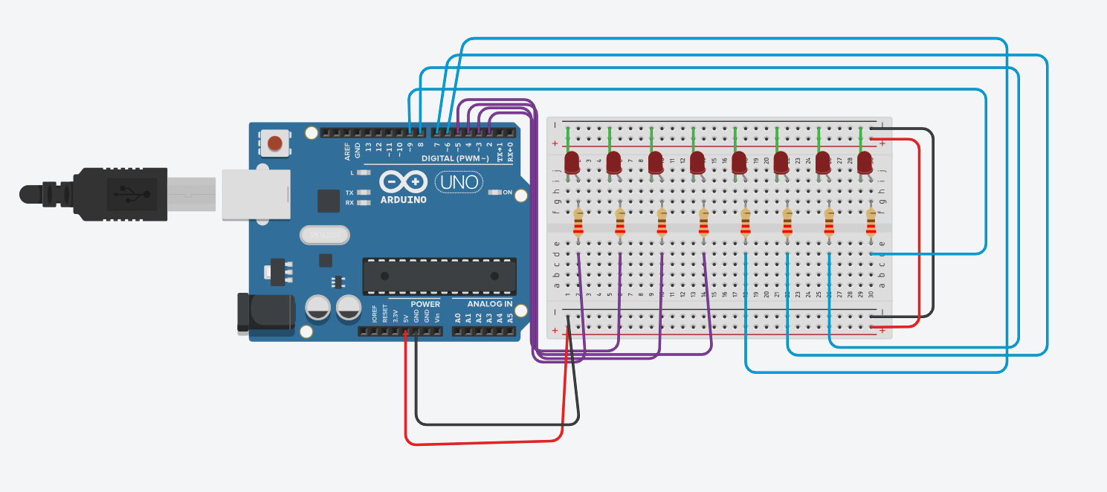

TINKERCAD Link:

https://www.tinkercad.com/things/bwyq6GN9aVA-lab-3/editel?sharecode=8XLniHgNaSzfW_8hZZUAdSPwQsohYw0fD2ac0-UCGdI